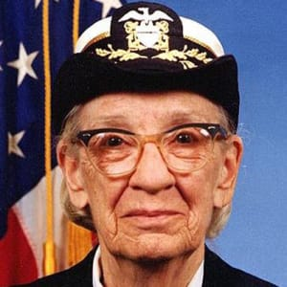
Who is Hopper?
Born December 9th 1906 in the city of New York, Grace Murray was a pioneer in the computer science industry, especially for women. Hopper had an interest I the field of technology from an early age and this keen interest remained right up until she died at the age of 85 in 1992. Her curious nature got the better of her when she was seven and dismantled 8 clocks to see how they worked, to the great displeasure of her mother no doubt. She was given the nickname “Amazing Grace” due to being a pioneer for computer science and her impressive naval rankings.
She was the eldest of three in her family and had a brother and sister, Roger and Mary. Hoppers love for maths is not surprising considering her father Walter and his father were both insurance brokers and her mother, Mary was the daughter of a civil engineer. Hoppers mother had a liking for maths but it was not proper at the time for a lady to follow such interests sand so her mother was limited to using maths to track the family finances, a role she took up in fear her husband’s health problems would leave her widowed.
Hopper married in 1930. She married Vincent Foster Hopper and took his name but later divorced in 1945 but she kept the name.

Education
If it were not for Hopper’s father, this essay may not have even been possible. He was the driving force behind her breaking the bonds on traditional ways and stepping out and beyond the traditional feminine role of abandoning ambition and the possibility of an advanced education. Without the encouragement from her father, Hopper may have never made such a significant impact on the computing world with the creation of the compiler.
Hopper attended Vassar College where she studied Mathematics and Physics. After graduating from Vassar with a B.A in 1928, she then went on to Yale where she studied for a Masters in Mathematics which she received in 1930 and received her Ph.D. in Maths four years later in 1934. She was the first woman in Yale to earn a Ph.D. in Mathematics, which just exemplifies what an outstanding woman she was and how much of an inspiration she is for women in STEM.

Career and Military Life
Hopper held a career as a professor at her old College, Vassar College, where she taught Mathematics from 1931 whilst continuing her studies. She remained in this position until World War 2 when she decided to lend her services to her country.
At age 35, Hopper attempted to join the military, however she was refused due to her being too old. However, she was not discouraged, her background in maths made her valuable to the military and her insistence on being enlisted and not just serve as a civilian won through in the end and in 1943, she was sworn into the U.S Naval Reserve.
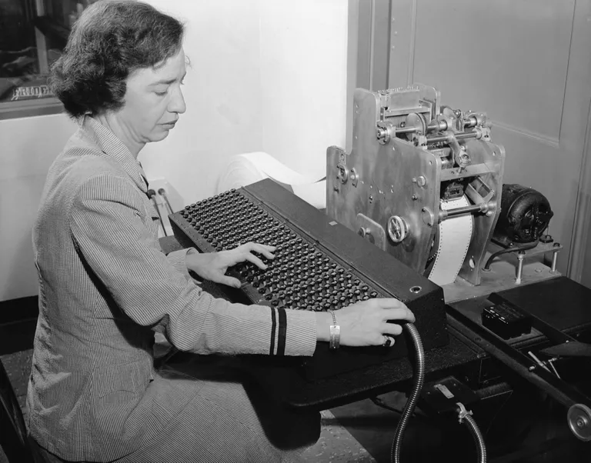
Hopper was made a lieutenant and assigned to work in Harvard on the Bureau of Ordinance Computation Project in 1944 due to her many degrees in the field of Mathematics. She was part of the team that worked on the first large-scale automatic calculator, Mark I with Howard Aiken, an American physicist and computing pioneer. After the war she continued on her work at Harvard with Mark II and Mark III computers with the Navy, as a reserve officer. The Mark computer was the machine where the first actual ‘bug’, a word Hopper coined, was found as a moth was discovered in the computer causing relays in the program.
In 1949, she moved into private industry, seeking to continue working with computers. She worked with the Eckert-Mauchly Computer Corporation. Hopper is well known for her work with the UNIVAC compute which she oversaw the programming after the corporation was taken over by Remington Rand in 1951.
In 1952, one of her most notable contributions to the computer science world was made, as she worked with a team that created the first compiler for computer languages which translated commands written in English into computer executable code. This compiler led on to the development of COBOL (Common Business Oriented Language). However, Hopper did not initially get the credit she deserved for such an achievement. In 1952 she had an operational compiler. "Nobody believed that," she said. "I had a running compiler and nobody would touch it. They told me computers could only do arithmetic."
Although Hopper originally retired from the Naval reserves with a commander rank in 1966, within a year she was recalled into duty to work on the standardization of the navy’s computer languages. In 1986, 20 years after her initial retirement, Hopper, at the age of 79, retired once more after rising through the ranks as Captain(1973), commodore(1983) and finally reaching the rank of Rear Admiral(1985, as the oldest officer on active naval duty, another great achievement in itself but extra commendable as a woman in my opinion!

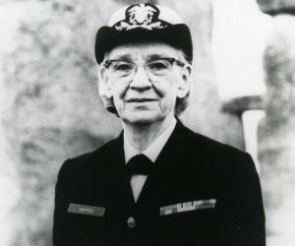
Awards and Recognition
Throughout her career Hopper received many awards, too many to list them all in this biography, between 1972 and 1987 she was the recipient of at least 37 honorary degrees. Hopper became a Fellow of the Institution of Electrical and Electronic Engineers in 1963 and in 1968 she received Achievement Awards from the same institution. She became Fellow of the American Association for the Advancement of Science in 1963 and in 1964 the Society of Women Engineers and the Institute of Electrical and recognised her with Achievement Awards.
In 1969 the Data Processing Management Association named her the first computer science ‘Man’ of the year and she received the Harry M Goode Memorial (a medal and $2000 award given by the society). In 1973, not only did Hopper become the first woman and the first American to be elected Distinguished Fellow of the British Computer Society, she also was elected to the National Academy of Engineering and the Legion of Merit.
Even in her final years, Hopper was an inspiration for women in technology. In 1991, Hopper made history becoming the first ever woman to receive the National Medal of Technology as an individual female. This is a notable win for women in the computer science area and surely has inspired many females to consider careers in technology in recent years. This was the last award Hopper received as she passed away in 1992. Further recognition was laid to Hopper, even after her death as she was awarded the Presidential Medal of Freedom in 2016.
Some less official recognition Hopper received includes The University of Missouri honouring her with a museum, ‘Graces Place’, on campus and the Navy in San Francisco commissioning The USS Hopper in 2004, a guided missile destroyer

Impact
Not only did Hopper leave her legacy as a programmer, she is also an inspirational leader for young people encouraging them to learn coding and programming skills. Hopper made such an impact on the world of computer science, especially for woman so much so that there is a technical conference named after her, The Grace Hopper Celebration of Women in Computing Conference which encourages women to join the computer science world.
Not only has Hopper been the recipient of many awards, she now has one dedicated to her, The Grace Murray Hopper Award is an accolade offered by the Association for Computing Machinery. This year,2019 Facebook also announced a scholarship in her name to attend the conference mentioned above in Orlando, the 2019 Facebook Grace Hopper Women in Computing Scholarship. This scholarship is actually the reason I know about Hopper, as when I heard of it, I was inspired to research who merited having such a scholarship named after them
Hopper made a huge contribution to the idea of women in tech, being the first woman to be recognised for her accomplishments and contribution to STEM such as her Ph.D. and her Presidential Medal of Freedom. The fact that there is a whole conference based around the idea of encouraging women to follow careers in computers epitomizes the impact she has had on spreading the idea of women in tech.
Not only was Hopper a true pioneer for computer science, she also broke the mould of what traditional ladies should pursue and be ambitious about. She essentially changed the way things were being done.
“The most dangerous phrase in the language is, "We've always done it this way."”

Bibliography
- ThoughtCo. (2019). Math Lover From an Early Age: The Younger Years of Grace Murray Hopper. [online] Available at: https://www.thoughtco.com/the-younger-years-of-grace-murray-hopper-4077488
- Dickason, E. (2011). CHIPS Articles: Remembering Grace Murray Hopper: A Legend in Her Own Time. [online] Doncio.navy.mil. Available at: https://www.doncio.navy.mil/chips/ArticleDetails.aspx?ID=2389
- Medium. (2018). Interpreters, JITS, & Compilers (Oh My!). [online] Available at: https://medium.com/fullstack-academy/interpreters-jits-compilers-oh-my-1bec4702995a
- Robertson, E. and O'Connor, J. (1999). Grace Hopper (1906-1992). [online] Www-history.mcs.st-andrews.ac.uk. Available at: https://www-history.mcs.st-andrews.ac.uk/Biographies/Hopper.html
- Biography. (2019). Grace Hopper. [online] Available at: https://www.biography.com/scientist/grace-hopper
- Thefamouspeople.com. (n.d.). Who was Grace Hopper? Everything You Need to Know. [online] Available at: https://www.thefamouspeople.com/profiles/rear-admiral-grace-murray-hopper-1536.php
- En.wikipedia.org. (n.d.). Grace Hopper. [online] Available at: https://en.wikipedia.org/wiki/Grace_Hopper#Dates_of_rank

